Table of Contents

Project Import Spreadsheets Manual 2

References Sheets 4

Current Limitations 5

Data Import/Export Manual

# **Project Import Spreadsheets Manual**

1. Download the Data Entry Import Sheet (The entry sheet should be under xls format). Since there are backend VBA code for the current version of the import spreadsheet, the xlsx format will take too long for Heroku to import data)
   1. [Data Entry Import Sheet.xls](https://unomail-my.sharepoint.com/:x:/r/personal/spawaskar_unomaha_edu/Documents/School/Teaching/Classrooms/23SP%20ISQA8950-002-MIS%20Capstone-CEPI/23SP-ISQA8950-002-Student%20Folder/Capstone%20Project%20Documentation/Sprint%20Deliverables/Data%20Entry%20Import%20Sheet.xls?d=wca0569a6e90a411784ba77cbc67b3c41&csf=1&web=1&e=QfFqGJ)
2. Enter new project data into the spreadsheet
   1. **Blue highlighted columns are mandatory** in order for the import sheet to work.
   2. Several columns must be entered as ID. The names of these columns are provided under the references sheet at the bottom of the page. In addition, these columns are marked with a pop-up for ID entry
   3. Leave the id (column B) blank since Django admin will auto-generate the project id.

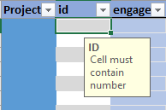

* 1. For validation purposes, there is a conditional formatting in place for the ID entry columns.

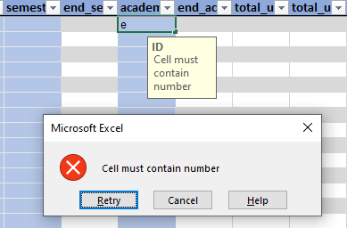

* 1. If users want to enter multiple id entry (such as community partners, campus partners, etc.), these numbers should be entered with a coma in the middle.

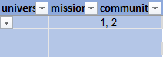

* 1. Save the import excel file after editing.

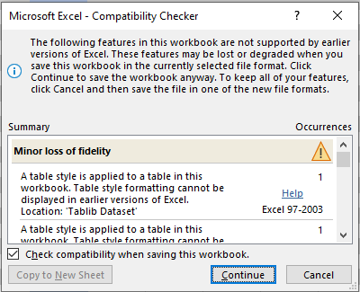

* + 1. Click Continue when the Compatibility Checker pop-up appears (due to the VBA backend VBA code).
    2. Make sure to save the file as **xls format.**

1. Log in with administrator’s credentials
2. Go onto the admin page
3. Click on Projects under Projects section

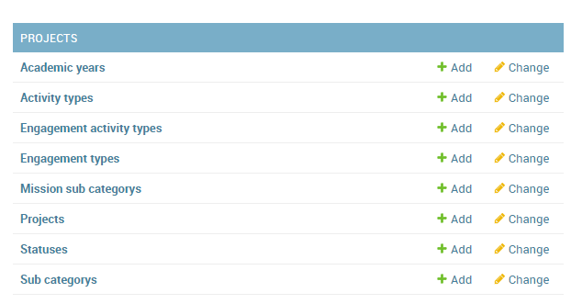

1. Click on Import button on the upper right corner of the page
2. Click on Choose File --> Choose the Data Entry Import Sheet file
3. Make sure the Format listed as xls

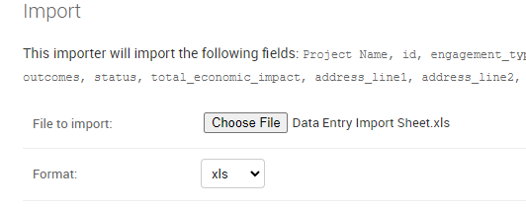

1. Click Submit
2. Click Confirm Import

# **References Sheets**

1. References sheet should be exported from Admin Panel
2. Click on the desired data table for prepare for export

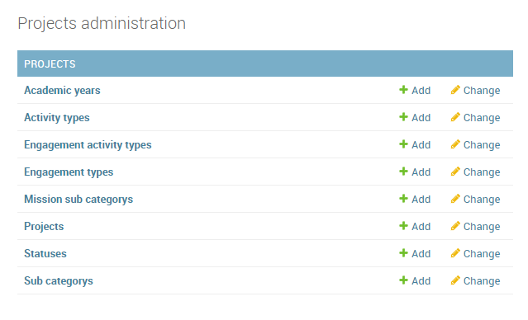

1. Click on Export at the top right corner
2. Click Format and choose a format for export

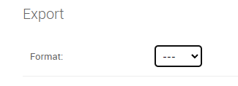

1. Click Submit
2. Open the downloaded file
3. Copy the id and name columns
4. Open the data entry import spreadsheet
5. Open the desired reference tab at the bottom of the page
6. Paste the information into the id and name columns in the reference sheet

# **Current Limitations**

1. Since there is a lot of project data, it is not feasible for Heroku to export all the project at once. Heroku only allows a webpage to load for 30 seconds, and it will create a request time out if it goes over the time limit. As a work around, administrators' user can export the project data by academic year.
   1. For the current Projects export function in the admin panel

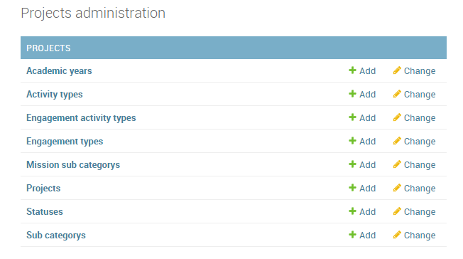

* 1. Administrators' user should click onto the Filter tab in the right side of the screen

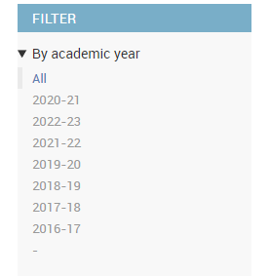

* 1. Select an academic year, choose an option
  2. Then proceed to export project